Activity report of induction program 2025

Name: Moosa

Father's Name: Mohd. Nazeer

Branch: Electronics and communication engineering ( ECE )

Registration Number: 2510713

Mobile Number (WhatsApp): 9877890312

Email: moosarajput2006@gmail.com

Photograph: 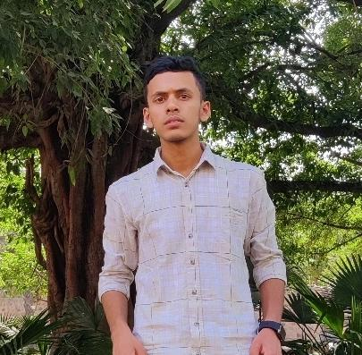

🟩 Day 1 (30 July 2025)

Session 1: "Why is the institute named after Guru Nanak Dev Ji"

The speaker explained that the institute is named in honor of Guru Nanak Dev Ji, the founder of Sikhism, to reflect his teachings of equality, humility, and service to humanity. The values of the college are inspired by his vision of wisdom and compassion.

Session 2: "How we are approaching our next four years"

In this session, the focus was on how students should plan their academic journey. The speaker discussed the importance of discipline, consistency, skill-building, and time management to make the most out of these four years and become responsible engineers.

Session 3: "History and Legacy of the Institute"

This session gave us insights into the rich legacy of GNDEC. We learned about its foundation, past achievements, contributions to society, and how the alumni have made their mark in various fields. It helped us feel proud to be a part of such a prestigious institution.

---

🟩 Day 2 (1 August 2025)

Session 1: Expert Lecture by Dr. Priya Darshni Madam on "Universal Human Values"

This session was deeply reflective. Dr. Priya Darshni talked about the core values that shape us as responsible individuals—like empathy, gratitude, and respect. She stressed that technical knowledge alone is not enough; being a good human is equally important in our journey as engineers. Her words made me think more seriously about personal growth and ethics.

Session 2: Expert Lecture by Dr. Jaswinder Singh (Incharge – IAPT)

Dr. Jaswinder Singh delivered a knowledgeable session focused on the importance of scientific thinking and curiosity in engineering. He encouraged us to question deeply, think beyond textbooks, and take part in scientific communities like IAPT. His examples and stories made the session very engaging and thought-provoking.

---

\*(Continue the same format for Day 3, Day 4... till last day)\*

---

\*\*Concluding Remarks:\*\*

The Induction Program was a wonderful start to my college journey. It helped me understand the values, rules, and future opportunities of the institute. I felt inspired and more confident. The sessions were well-organized, and each speaker left a strong impact. I thank the college and the organizing team for this memorable experience.